Q1 THEORY EXPLANATIONS

I SETA) A binary tree has the following traversals:
In-order: 4, 7, 8, 5, 2, 9, 3
Pre-order: 5, 7, 4, 8, 9, 2, 3
What is the right child of the root? a) 7 b) 5 c) 9 d) 2

Answer: c) 9
Explanation: In Pre-order, the first element is always the root.
Pre-order: 5, 7, 4, 8, 9, 2, 3
So, root = 5.
Now split the In-order traversal around 5:
In-order: 4, 7, 8, 5, 2, 9, 3
Right subtree: 2, 9, 3
Now look at the corresponding right-subtree part in Pre-order: 9, 2, 3
The first node there is 9, so 9 is the root of the right subtree.
Therefore: Right child of 5 = 9
_____________________________________________________________________________________________________________
II SETA) A BST is built by inserting the following keys in order: 10, 5, 15, 3, 7, 12, 18. What is the height of the resulting tree? a) 2 b) 3 c) 4 d) 6
Answer: a) 2
Explanation: The BST becomes:
10
/ \
5 15
/ \ / \
3 7 12 18
The longest path has 2 edges, so the height is 2.
________________________________________________________
III SET A) An undirected graph (no self loop) has 7 vertices. What is the maximum number of edges it can have?
a) 6 b) 21 c) 14 d) 49
Answer: b) 21
Explanation: Maximum edges in an undirected graph with no self-loop = n(n−1)/2.
For 7 vertices: 7×6/2 = 21. ________________________________________________________
IV SETA) A fully connected graph has 9 vertices and 12 edges. By removing how many edges will this graph be a tree? a) 1 b) 2 c) 3 d) 4
Answer: d) 4
Explanation: For a tree, no of edges == no of nodes - 1. A tree with 9 vertices must have 9−1 = 8 edges. The graph has 12 edges, so remove 12−8 = 4 edges.
____________________________________________________________________________________________________________
V SETA) The worst case time complexity of insertion in a BST and Heap is the same. a) True b) False
Answer: b) False
Explanation: Worst-case BST insertion is O(n) if the tree becomes skewed, while heap insertion is O(log n). So they are not the same.
________________________________________________________________________________________________
SET A: Consider the given Binary Search Tree on the left
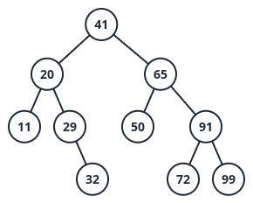
VI) If 30 is inserted into the BST, will the tree become unbalanced? Write yes or no with a brief justification.
VII) Draw the tree after deleting 20 from the given BST. (ignore the insertion in VI)
VIII) after (VII) operation, delete 29 from the BST and draw the tree again.
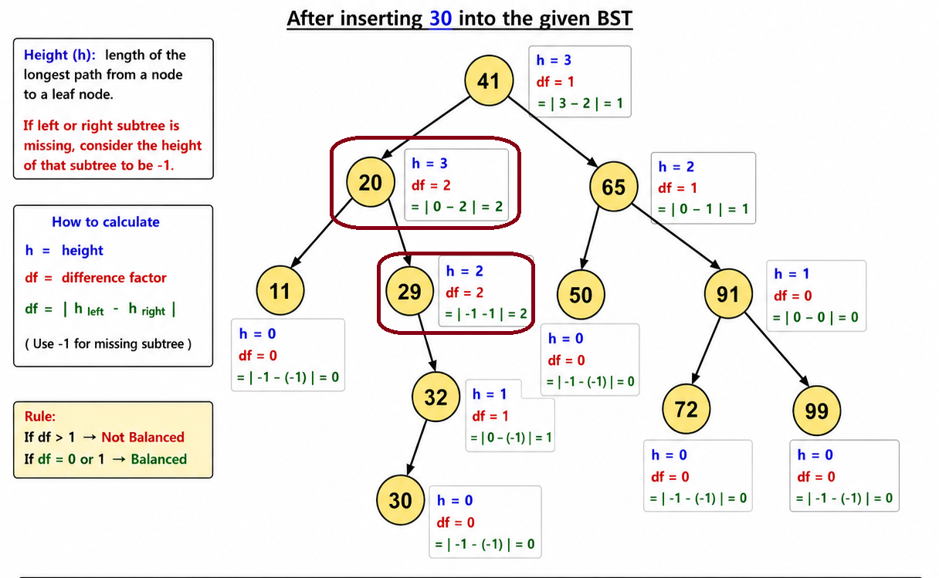

Solution Using Successor: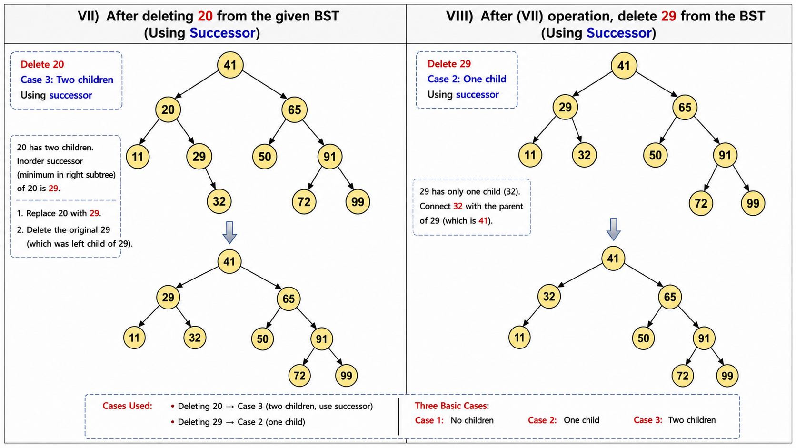
Solution Using Predecessor:
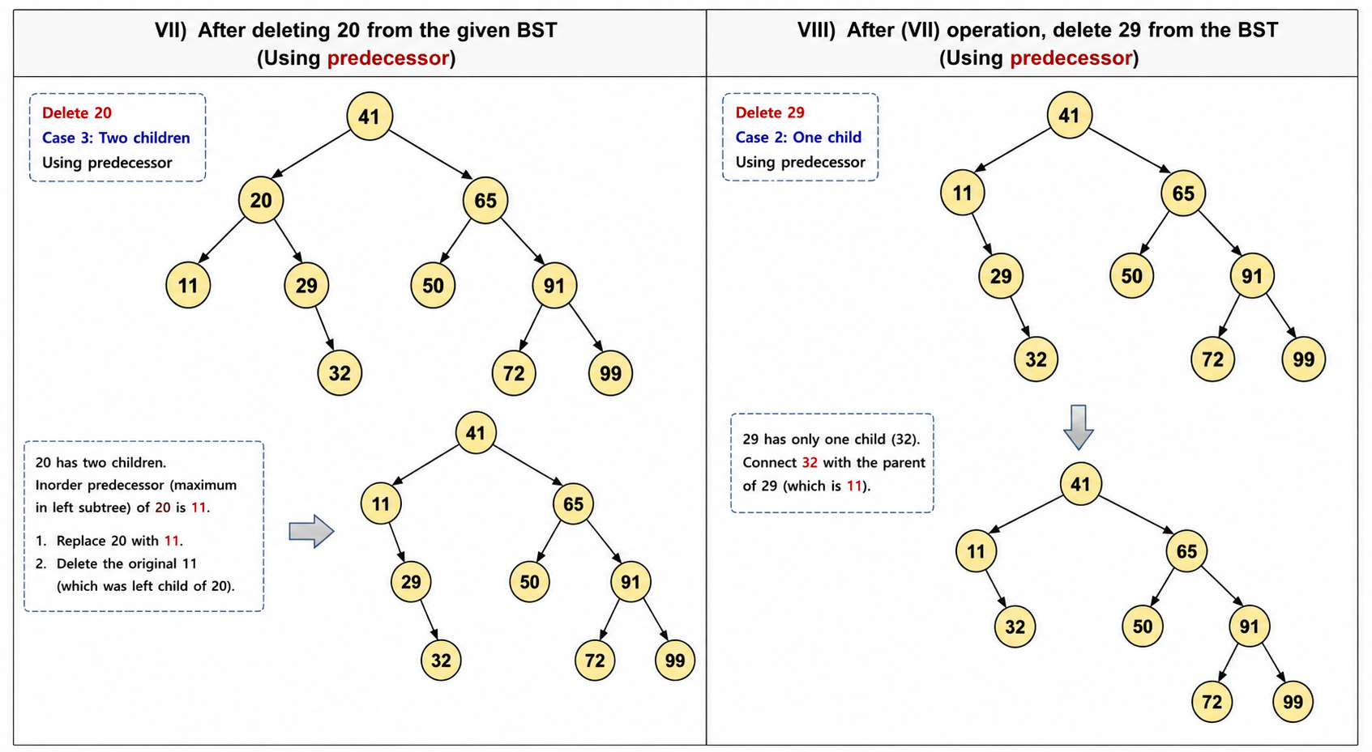

_____________________________________________________________________________________________________________
SETA: Consider the given undirected weighted graph on the left where the vertices are labeled using numerical values:
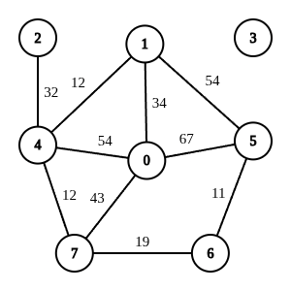
IX) Draw the Matrix representation of this graph.
X) Show the traversal sequence of performing a Depth-First Search (DFS) traversal starting from the vertex 6.
When a vertex has more than one neighbor, you can choose the next neighbor based on the descending order of the numerical label on the vertices.
XI) Which edges were NOT traversed during your simulation? Write down their sources, destinations & weights.
For example: <5 - 0 : 67> means an edge from 5 to 0 with 67 weight.
